Making Visuals with dY from DesignBuilder Results

Annual Hourly Heatmap Tutorial

# Steps

1. Export and Save Your Results
2. Tell dY what to use for the Visual
3. Make Visual

# CliffNotes Version (Reminder for Subsequent Uses)

1. Export annual hourly grid data (building and/or zone). Save as CSV.

2a. Verify dY and Heatmap folders are saved in the same place.

2b. Open script file, edit line 47 with the exact ‘key’ for the data for your heatmap. Save.

3a. Drag index-db file to an open browser window.

3b. Select the file to generate the heatmap from.

# Full version (For First Use)

## Step 1: Export and Save Your Results

1. Run an annual hourly simulation in DesignBuilder.
2. On the Analysis tab of the results, in Display Options, select Hourly and Grid. (Figure 1)

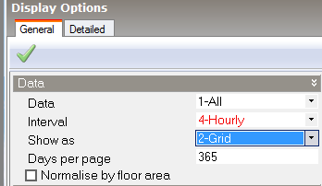

Figure 1

1. Under Info: Help select Export. (Figure 2)

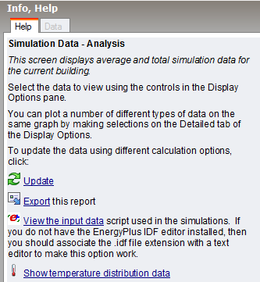

Figure 2

1. In the dialog box, make sure the selected options are Export to File and Format: CSV Spreadsheet. Click OK.
2. Give your file an appropriate name.
3. If desired, repeat the above steps B-E for each zone in your building. Save all resulting files in the same location.
4. Open the file you wish to make the visual from. You will not be editing it, ‘read only’ mode in Excel is fine (you may have to go through an import process to make the CSV file type readable).

## Step 2: Tell dY what to use for the Visual

1. Download and save the following 2 folders in the same place:

* dY
* Heatmap[1]

1. Open the Heatmap folder. You will be working with 2 of the files in this folder.
2. Open script.js using Notepad++ or another text editor.
3. Setup the zonekey on line 48. (Figure 3)
   1. Replace SimpleHouse with the exact name of the CSV file. If your CSV file is named MyBuilding.csv, replace SimpleHouse with MyBuilding.
   2. Replace Operative Temperature[C] with the exact heading and cleaned units of the column of data you want to use. Look at the file you have opened, and enter the following: exact column name (including spaces) immediately followed by the units, in brackets, with special characters (‘/’, ‘°’) omitted.
      1. Example 1:

Row 1: Radiant Temperature

Row 2: °C

zonekey 2nd entry = Radiant Temperature[C]

* + 1. Example 2:

Row 1: External Infiltration

Row 2: kW

zonekey 2nd entry = External Infiltration[kW]

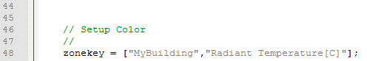

Figure 3

1. Save script.js with no change to name or location

## Step 3: Make Visual

1. Drag the file index-db.html into an open browser window.
2. Refresh your browser window.
3. Press Choose Files and select the file you want to use to for the visual.
4. If visual doesn’t appear, complain to Kyle Steinfeld.

1. If using these instructions for a non-heatmap visual, ensure that visual’s folder is in the same location as dY